If user choses option 2, to display all students, without adding any student in the records list, then following message is displayed:

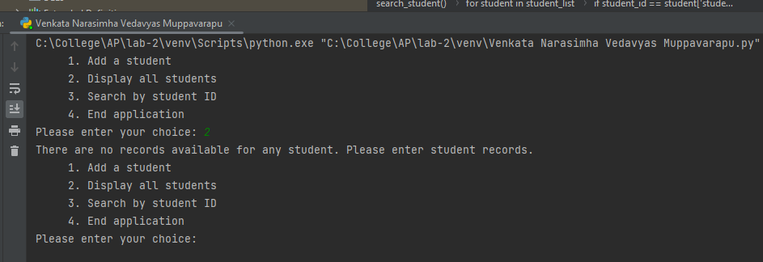

If user choses option 3 to search student by student ID (but there are no students in the list or list is empty) then following message is displayed:

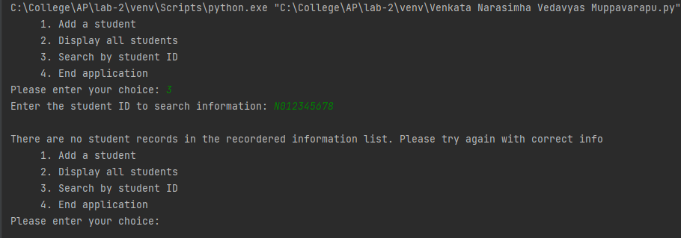

Following shows that if user does not enter correct format of student ID, (e.g. valid student ID starts with ‘N0’…..)

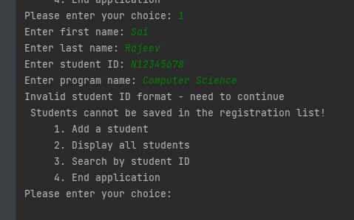\

If user enters student ID that is not 9-characters, then again following message is displayed:

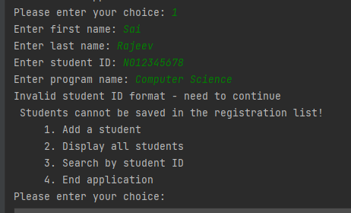

In the following example, if user enters lower case ‘n’, again student is not added to the record list:

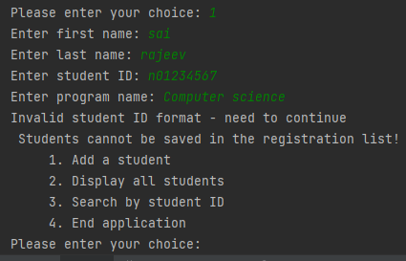

If student number (ID) is valid and student ID is not already in the record list, then following students are added to the records list:

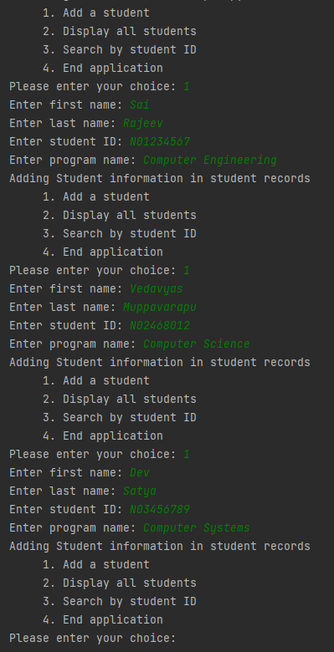

When user choses option 2, complete record of students is displayed. This is shown below:

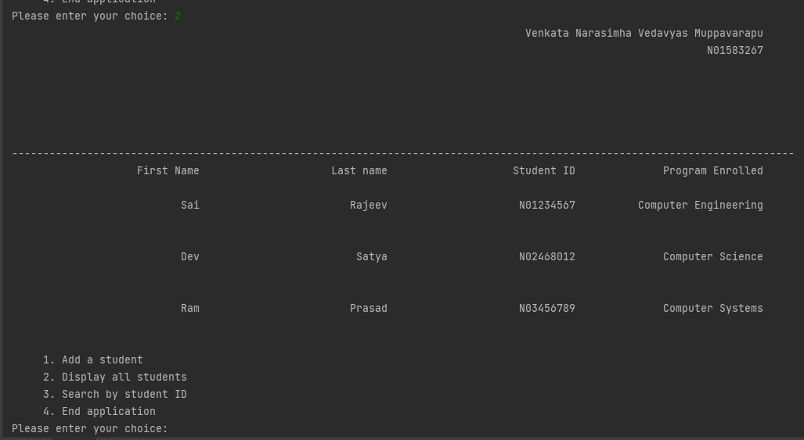

If a student needs to register but the student ID already exists, then student is NOT added and the following message is displayed because student is already enrolled and is part of the records list. The name may or may not be the same, as system checks for student ID to differentiate valid student information to enrol in the system.

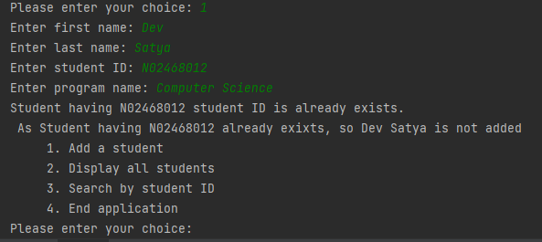

When user choses option number 3, to search a student by student ID, following is displayed if student record search is successful:

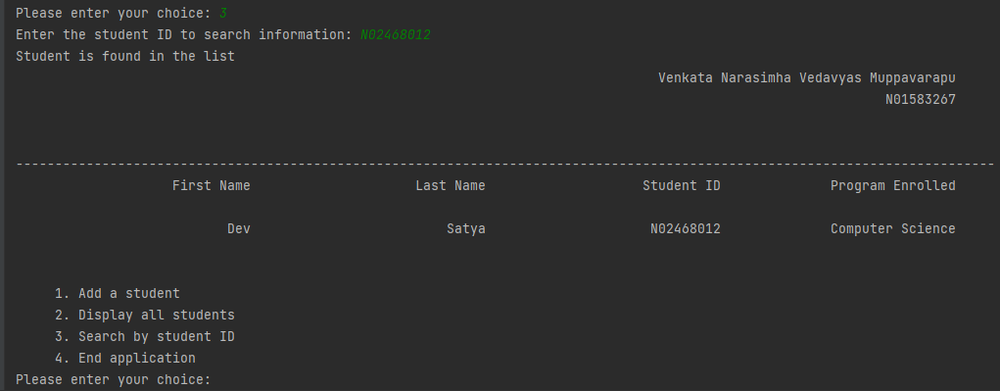

If the student (searched by student ID) is not in the given list, then following message is displayed:

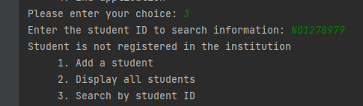

If user enters choice (instead of 1, 2, 3 or 4) that is different from the requirements in the application, following message is displayed (“***Enter correct option***”):

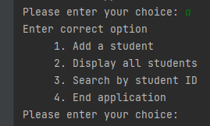

When user choses option 4 to end the application, your program displays the message that it was ending and ends the application. This is shown below:

